KS02 -

Functionality
A Cost Center is an organizational unit within a controlling area that represents a defined location of cost incurrence. The definition can be based on:
- Functional requirements
- Allocation criteria
- Physical location
- Responsibility for costs

Scenario
This Transaction is used to change the cost center master data. A list of changes is recorded as time dependant data, this is used to keep an audit trail of changes made and by whom they were made.

Requirements
Cost center must exist.

Menu Path | Accounting → Controlling → Cost Center Accounting → Master Data → Cost Center → Individual Processing → KS02 - Change
Transaction Code | KS02

1. Double Click on KS02 - Change

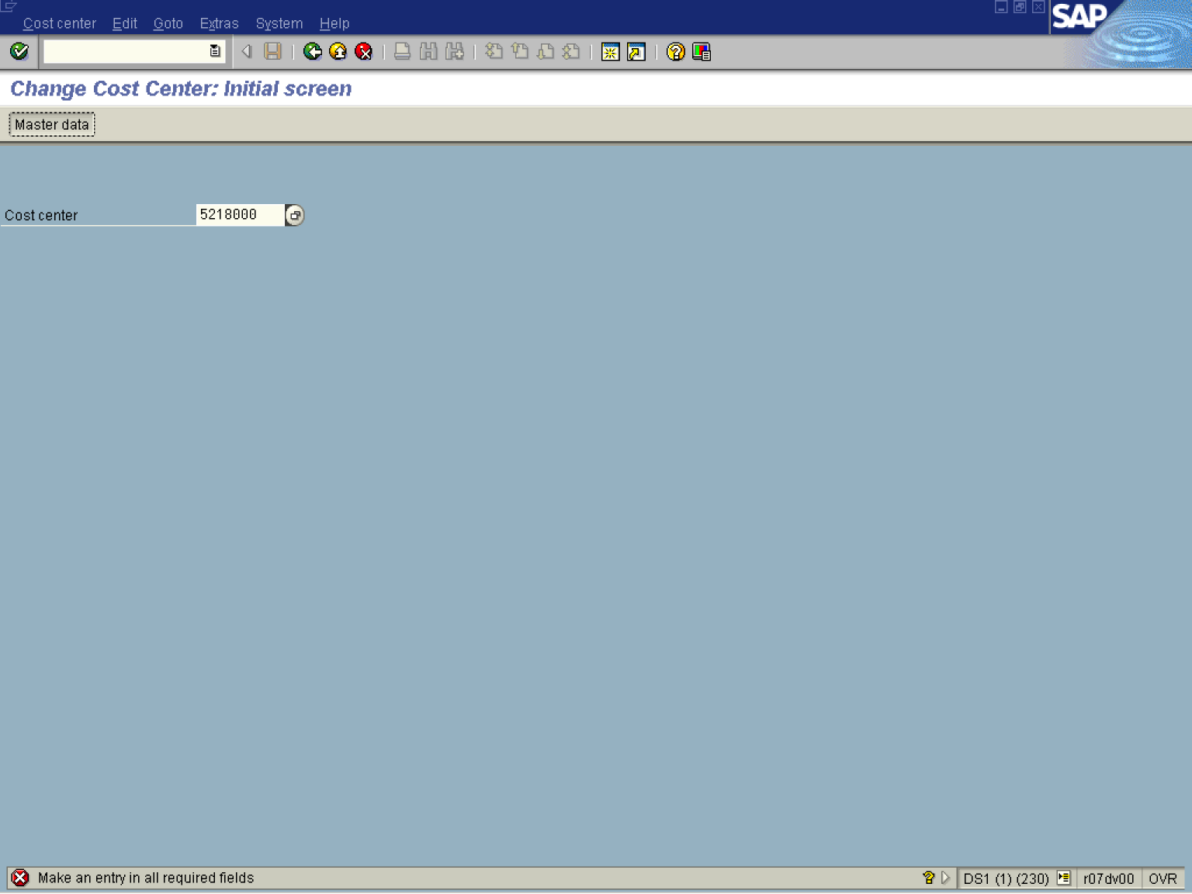

2. Update the following fields:

Field Name | Field Description | Values
Cost center | Code identifying an organizational unit to which costs or assets are assigned | Example: 5218000

3. Click Master data Button .

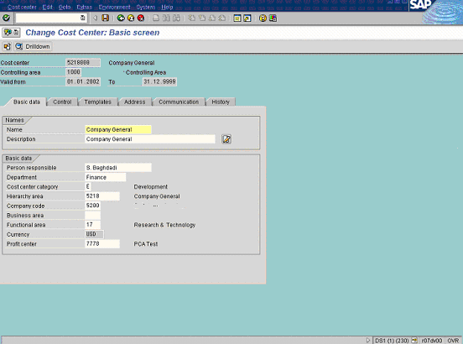

Note: All white fields can be changed. Grey fields cannot be changed. The currency value defaults from the predefined company code currency.
4. Update the following fields:

Field Name | Field Description | Values
Department | Department responsible for managing the cost center. | Example: Finance

5. Click Enter .
6. Click <tab button> Address .

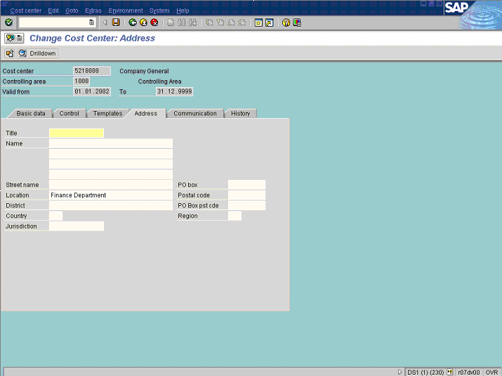

7. Update the following fields:

Field Name | Field Description | Values
Location | Code identifying a location in the company | Example: Finance Department

8. Click Enter
9. Click <tab button> Communication .

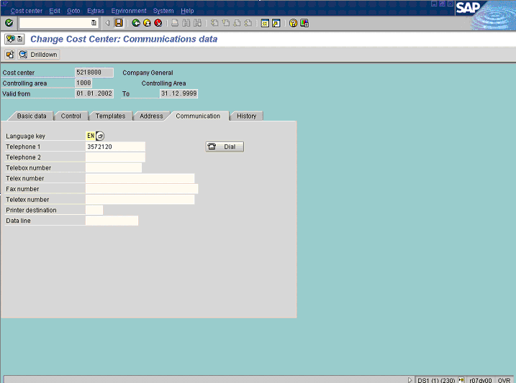
Note: Cost center owner contact details are entered on this screen.
10. Update the following required and optional fields:

Field Name | Description | Values
Telephone 1 | Description of the Telephone 1. | Example: 3572120

11. Click Enter
12. Click Save

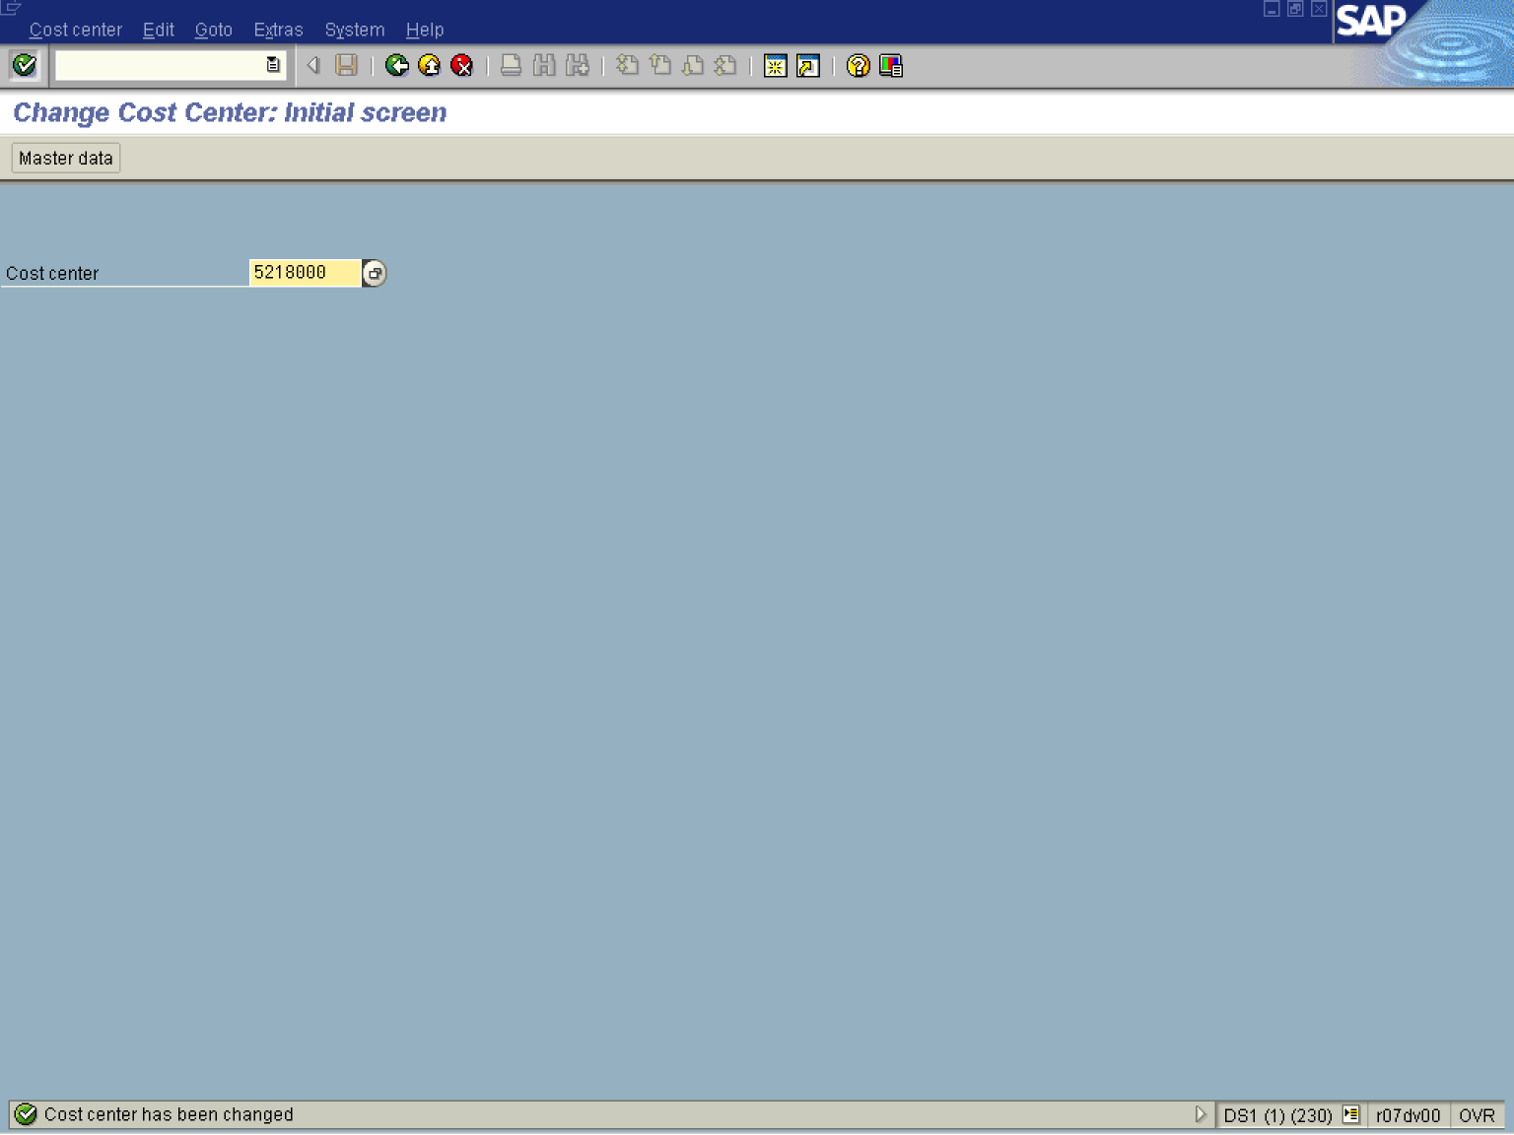

13. The message bar displays “Cost center has been changed”

